Introduction of Cobb Ecological Academy (Sunshine Ecovillage):
A Different Education is Possible

We all participate in and contribute to the times in which we live, as we aspire for our own destiny. With reflection and discernment, our minds free us from concerns yet doubts still trouble our hearts. Where is the distant poetic beauty?

There is a rural life, where traditional wisdom listens to the wind and appraises the moon for shifting environmental conditions; where a new generation of farmers are stepping on the live-giving ground and harvesting its seasonal yields. It is both local and global, and it can heal and rebuild the beautiful countryside while allowing us to reconnect with the earth.

In the Sunshine Ecovillage, you can talk and listen to perceptive men and women who can offer practical knowledge and help you navigate the trails of life. Imbuing traditional wisdom with the latest communitive technology, this learning community blends in-person and online instruction.

Participants will experience a different lifestyle, fostered by a strong, committed community that has a profound local impact. As this promising education inspires more people, more and more ecological villages will appear instilling new values and lifestyles that will be universally emulated. This is the turning point of social change.

Removing ourselves from the current consumerist model and returning to a cultivating of living persons, we will see a paradigm shift in human development. There levant knowledge and technology are already available; what is needed is the imagination and exploration of ecological lifestyles.

Cobb Ecological Academy (Sunshine Ecovillage) will be the place where your life and the world turn for the better. Your destiny awaits you.
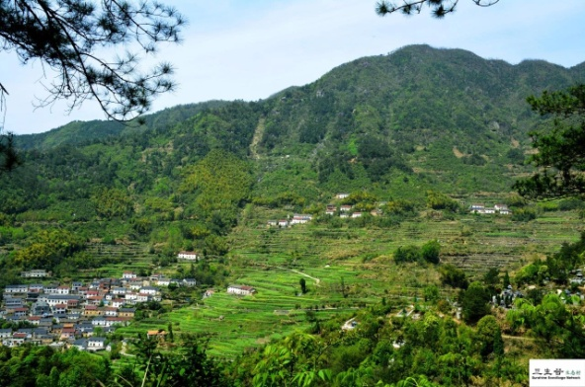

The location of Cobb Ecological Academy (Sunshine Ecovillage)

—Introduction to Cobb Ecological Academy (Sunshine Village)—
This is a school without walls – the entire village, forest, and valley and beyond is our campus;
This is a school that will allow students to connect with the fields and learn under ancient eucalyptus trees;
This is a school that seeks to unify practice and theory;
This is a school that does not offer a degree but eco-certificate;
This is a school with 20 students on the campus each year and dozens of professors from all over the world;
This is a school where academics, professors, experts, workers, and farmers come to serve as practical teachers;
This is a school that not only invites teachers and students to fruitfully exchange ideas, but also encourages peer learning;
This is a school that emphasizes building a learning community for mutual benefit and growth;

This is a school that encourages students to study with inspiration and creativity, to gain self-confidence through implementation of vision planning, program studies, classroom design, among other possibilities.

We are located in the beautiful countryside, practicing rural revitalization strategies that cultivate the younger generation who are willing to return to the countryside for a richer life experience;

Here, we experience the valley but feel the whole world, exploring the relationship between climate change and human lifestyle, practice and theory, all the while building a community for a better future;
We intently discuss the issues of sustainable development and happiness of human beings thereby creating an "ecological person" with confidence, sensitivity, and practical wisdom.

The Academy was established on October 3rd, 2018 and is proudly co-sponsored by
John B.Cobb, Jr, the Institute for Postmodern Development of China, Sunshine Ecological Village, and Global Ecovillage Network.

Mission

The Academy integrates the concept of three Shengs（三生）: Life(生命), Ecology（生态） and Livelihood（生活). Based on Eastern wisdom and the philosophy of organism, the Academy has a strong educational structure espousing a flourishing Ecological Civilization. The IPDC provides a unique ecological civilization curriculum while the curriculum of the eco-village design education (EDE) of the Global Eco-Village Network and UNESCO's Education for Sustainable Development (EDS) transforms participants into Eco-Persons, with dreams, ideas, sensitivity, and hands-on skills. The goal of the Academy is to create young leaders who are rooted in their land and traditional culture, but strive for global interconnection.

The meaning of Three Shengs: Life, Livelihood and Ecology

Education for life (生命)
This aspect aims at cultivating “Tongren”(通人) who is a unified person of body, feeling, mind and spirit. Thus the participants will find the true meaning of their life and happiness and learn that education in its truest from is not about money, or a job, but a better quality of life.

Education for Ecology（生态）
This aspect aims at cultivating an eco-person who reconnects the harmonious relationship between the self and others, people and society, humankind and nature, from "ego" to "eco", "I" to "us”, competition to collaboration. It promotes the idea of “survival of the harmonious”, not “survival of the fittest”.

Education for Livelihood（生活）
This aims at instilling a person with creativity, practical skills and wisdom, in order to help them to live more fully. As Alfred North Whitehead points out, “the only subject matter of education is colorful life."

Vision
The Academy promotes the transition from industrial civilization education to ecological civilization education. It says “No” to modern education that:
focuses on individual not community;
focuses on city not rural life;
focuses on knowledge not wisdom;
focuses on the particular not the general;
focuses on competition not harmony;
focuses on knowing not doing;
focuses on modernity not traditions.

The difference of an eco-education is captured in the diagram below:
 | 现代工业文明教育  Modern Education | 后现代生态文明教育  Postmodern/Eco Education
哲学基础/  Philosophy | 机械哲学/  Mechanism | 有机哲学/  Organism
科学基础/  Science | 牛顿力学/  Newton Theory | 量子力学/  Quantum Theory
文明类型/  Civilization | 工业文明/  Industrial Civ. | 生态文明/  EcoCiv
模式/Model | 经济模式/  Economic | 有机模式/Organic
重点/Focus | 城市/City | 地方/Local
社会制度/  Social System | 资本主义/  Capitalism | 社会主义/  Socialism
宗旨/Mission | 知识/Knowledge | 智慧/Wisdom
目标/Aim | 专才/  Specialization  学历教育 / 工作培训 | 通人/  Tong Ren  生命成长
产品/Product | 经济人/Homo economics | 生态人/  Eco-persons
方法/Method | 填鸭式/  Forced feeding style of teaching | 启发式/Heuristic Method
This价值/Value | 价值中立/  Value Free | 价值教育/Value Education
学科/  Discipline | 学科崇拜/Disciplinolatry | 跨学科/Transdisciplinary
传统/  Tradition | 抛弃或贬低传统  Abandonment of the tradition | 尊重传统，鼓励传统与时俱进发扬光大  respect tradition
评估/  Evaluation | 标准化/  Standardization | 多元化/Pluralism
—三生谷柯布生态书院成员—

—Structure of the Cobb Ecological Academy (SunshineVillage)—
Lifetime Honorary President: Academician John Cobb
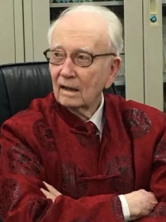
Dr. Cobb is a world-renowned constructive postmodern thinker, ecological economist, and process philosopher. He is co-founder of the Center for Process Studies, the founding president of the Institute for Postmodern Development of China, and a member of the America Academy of Arts and Sciences. For many years, Cobb has engaged in process philosophy, postmodern culture and ecological civilization research, and has published more than 50 books. His research on ecological civilization has made great impact worldwide, especially in China.

Honorary President: Prof. Zhang Xiaode
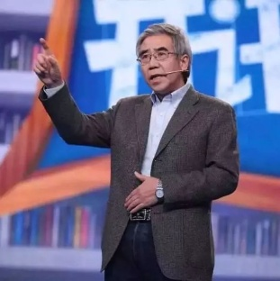

Professor at the Chinese Academy of Governance, deputy Secretary General of the China Public Economic Research Association; Standing Committee of China Ecological Civilization Research and Promotion Association. He primarily engages in the study of ecological civilization and ecological economy, rural civilization and rural economics, and so forth. He is one of the earliest scholars in the field of ecological civilization in mainland China.

President: Dr. Fan Meijun
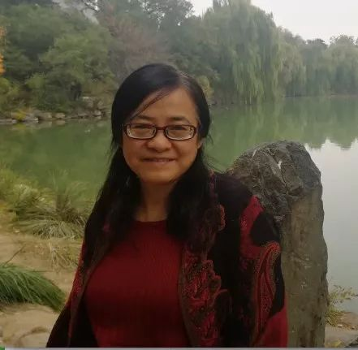
Dr. Fan is the co-director of the China Project at the Center for Process Studies, Claremont; the program director of the Institute for Postmodern Development of China; the editor-in-chief of Cultural Communication, a Chinese newspaper. She completed her doctoral studies at Beijing Normal University and masters program at Peking University. Her areas of specialty include Chinese traditional aesthetics, process and aesthetics education. She has authored several books including: Contemporary Interpretation of Chinese Traditional Aesthetic (1997), The Popular Aesthetics in Qing Dynasty (2001), and The Second Enlightenment with Zhihe Wang (2011).
She was a professor at Beijing Normal University and recipient of the “China Excellent Teacher” award from both the Baosteel Education Foundation (1995) and Tsang Hin-chi Education Foundation (1999).

Secretary General: Mr. Wang Haichao
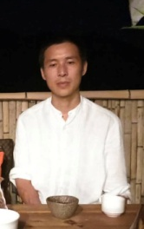
Mr. Wang Hichao is an initiator of Sunshine Ecovillage which is the first ecovillage in mainland China and a member of GENOA- Global Ecovillage Network Oceania & Asia.

— Proud co-sponsors of Cobb Ecological Academy (Sunshine Village)—
The Institute for Postmodern Development of China (IPDC)
The Institute for Postmodern Development of China (IPDC) was incorporated as a 501(c)(3) nonprofit organization in 2005 to create and promote new modes of development in China and the West. Using ideas that integrate classical Chinese philosophy with constructive forms of Western thought, the Institute addresses practical problems associated with economic growth, social change, and globalization. China is rapidly absorbing ideas and technologies from the West. Chinese universities, research institutes, and government agencies have adopted Western textbooks and models of analysis, organization, and management.
IPDC is based in Claremont, California. It has hosted numerous Chinese-American conferences in both U.S. and China on ecological civilization, green development, reform of higher education, postmodern agriculture, and social responsibility in business, dialogue between science and spirituality, etc.

Global Ecovillage Network

The Global Eco-Village Network is an organization that promotes environmental and natural reshaping. It hopes to use the concept of eco-village as a model of sustainable human settlements to realize the harmonious desire of harmonious coexistence between man and nature. The organization actively supports the construction of eco-villages and their networks around the world.
Sunshine Ecovillage

Sunshine Ecovillage is a social enterprise dedicated to the practice of rural revitalization strategy and ecological civilization education. It was established in Hangzhou, China in 2015. A partner of the Global Eco-Village Network, UNESCO, the initiator of the China Eco-Village Network. Its mission is to provide systematic and localized solutions for rural revitalization, to cultivate a full-scale design of rural-activated eco-villages, and to promote the construction of 100 ecological villages.
—The Teachers—
Teachers from abroad:

Albert Bates
A world-class Pumen master and the founder of the Technology Global Village Institute, he has worked as a lawyer for 20 years, during which he has studied environmental and human rights issues, including the Paris Agreement and the Post-Oil Survival Guide. He is the former chairman of the Global Eco-Village Network and is currently the director of the Eco-Village Training Center. He wrote the content of the ecological dimension in the four dimensions of Gaia Education Ecological Village, and wrote the chapter of Pumen Perpetual Agriculture in The State of the World 2010.

John Berthrong
Professor at Boston University, he is the theoretical representative of Confucianism in Boston, USA, and author of Caring for Creation: Comparing Zhu Xi, Whitehead and Nan Leshan.

Paul Bube
He is a Process Philosopher and professor at Lyon College, USA. His research interests are: Process Philosophy, Process Education, Ecological ethics and ecological civilization.

John B. Cobb

Clifford Cobb
Senior Research Fellow at IPDC. A well-known American eco-economist, an expert in social public policy, sustainable development and land study. He was former chairman of the SchalkenbachFoundationand is the editor-in-chief of the American Journal of Economics and Sociology. His main works are Green GDP (with John Cobb) (1993), The Road to Justice - Henry George's Philosophy and Economics (2001), Open Schools, Renewed Communities(1992), System Education Reform - A Communicative Program (1993). He is one of the earliest proponents of the green GDP concept in the Western world. In 2004, he was selected along with Rachel Carlson, the author of Silent Spring, as one of the most insightful thinkers of the 20th century.

Philip Clayton
President of Institute for Postmodern Development of China, also president of Institute for Ecological Civilization,, USA. Clayton has taught or held research professorships at Williams College, California State University, Harvard University, Cambridge University, and the University of Munich. His research focuses on biological emergence, religion and science, process studies, and contemporary issues in ecology, religion, and ethics, particularly the societal changes that are necessary for establishing sustainable forms of civilization on this planet. He is the recipient of multiple research grants and international lectureships. He has authored or edited 24 books and published some 300 articles as well as the author of numerous books.

Kosha Joubert
CEO of GEN, Global Eco-Village Alliance. Formerly of the University of Tübingen in Germany and the University of Amsterdam in the Netherlands, she studied linguistics, cultural anthropology and organizational development. She is now committed to promoting the development and concept dissemination of new ecological villages on all continents. She is the author of Ecological Village - 1001 Ways to Heal the Earth.

Kim Jae-Hung
Korean writer, Yi Jing research scholar, natural education tutor. He is the author of The Book of Changes. He established "Bag School" and "Nüwa Nature School".

David Korten
A well-known American eco-economist, a former professor at Harvard Business School, a member of the Rome Club, and the author of the book When the Company Ruled the World, the leader of the US New Economic Movement.

Jay McDaniel
He is the Willis Holmes Professor of Religion at Hendrix College in Conway, Arkansas, where he also serves as the Director of the Marshall T. Steel Center for the Study of Religion and Philosophy. He specializes in Buddhism, Whiteheadian process philosophy and process theology, constructive theology, ecotheology, interfaith dialogue, and spirituality in an age of consumerism.

Paura Robert
Head of UNESCO East Asia.

Stephen Rowe
Professor of philosophy at Grand Valley State University in Michigan. His major works include Leaving and Returning: On America's Contribution to a World Ethic, The Vision of James, Living Philosophy, Rediscovering the West, Overcoming America / America Overcoming: Can we Survive Modernity?

The teachers from China

AnJinlei
He is actively practicing and promoting ecological agriculture in his hometown, Hebei, and is known as "the first ecological farmer in China." He is also the recipient of the "Cobb Common Good Award" in 2016.

Chen Guangrong
A local villager and farmer who maintains traditional farming skills while intensively and skillfully integrating new ideas, both. He is rooted in the land and the wisdom of the farm.

Guo Haipeng
He is a professor at United International College. His study and focus are Chinese tradition and culture.

Hu Yuegao
As a professor at China Agricultural University, he has long been engaged in regional agricultural development strategy research. In 2013, he organized the “Lingqiu Organic Agriculture Park Implementation Plan” and actively participated in the theoretical research and practical exploration of the global organic agriculture construction.

Huang Haifeng
He holds a Ph.D.in philosophy from Humboldt University, Berlin, Germany and is Professor at HSBC Business School of Peking University. His research interests include economic transformation, sustainable development, regional economy, green economy and finance.

Huang Yi
She is professor in the School of Economics at Anhui University. Her research focuses on ecological economy and local economy.

Ji Xi
She is a professor at Peking University. Her major interest is ecological economics.

Lai Xianzong
He is a Taipei native who received his Ph.D. degree from the University of Taiwan and the University of Munich in Germany. He is currently a professor at the Department of Chinese Literature at Taipei University. He has published many academic books, such as Taoist Hermeneutics, Buddhist Hermeneutics, and Confucian Hermeneutics. Confucian teacher: Tom Fang - Cheng Zhongying - Lai Xianzong, and, XiongShili – Mou Zongsan - Lai Xianzong. He has successfully applied Chinese and Western philosophy to the study of Taoist aesthetics and has achieved great results in the topic of "Intercultural Communication between Heidegger and Taoism".

Li Changping
Li served as a reporter and editor of China Reform and Reform Internal Reference. He is currently the Dean of the Chinese Rural Construction Institute, a researcher at the China Reform Research Association, and an adjunct professor at Zhongnan University of Economics and Law.

Sheri Xiaoyi Liao
She is the founder of “Beijing Global Village”, a private environmental protection organization. She holds her Master of Philosophy from Sun Yat-Sen University, honorary Doctor of Law at Fairfield University, USA, and founder of Beijing Lehe Social Work Service Center. She was awarded the "Sophie Award" in the Norwegian International Environmental Awards 2000, the "Benkesia Award" in 2001 for Australia's highest environmental award, the Clinton Foundation's "Global Citizen Award" in 2008, and the "Cobb Common Welfare Award" in 2006. In 2015, she won the “Public Welfare Person of the Year Award” at the 5th China Public Welfare Festival.

Liu Yuedi
He is currently a researcher at the Institute of Philosophy of the Chinese Academy of Social Sciences, a Fulbright scholar, and a postdoctoral fellow at Peking University. He was one of the five executive committee members of the International Association of Aesthetics (IAA) and the deputy secretary-general of the China-Canada Society. He is one of the leading figures in the field of everyday aesthetics in China.

Liu Xiaoting
He is a professor at Beijing Normal University. He is a noted scholar in the field of science and spirituality.

Lu Feng
Lu is Ph.D in Philosophy, professor at Tsinghua University, Executive Director of the Center for Ecological Civilization Studies of Tsinghua University, and Director of the Environmental Philosophy Committee of the Chinese Society of Dialectics.

Lu Shuyuan
Prof. Lu is the winner of the 11th John Cobb Common Good Award (2018). He is director of the Research Center for Eco-Culture Studies, and Director of the Center for Constructive Postmodern and Ecological Culture Studies at Huanghe University of Science and Technology, Henan, China.Prof.Lu is a noted eco-critic in China and a leading figure in China’s Ecological Movement. He is a founder of both Spiritual Ecology and Ecological Literature and Arts in China.
Ren Weizhong
The principal of the Soil School, a local ecological construction expert, director of the Zhejiang Anji Earth Building Research Center. Committed to the research and exploration of clay materials and bauxite buildings. He also built a number of bauxite buildings at the base of Anji, with an experimental studio for the development of clay materials. Ren Weizhong did not systematically learn architectural knowledge, but his deeds and his houses were well known in the construction industry, and he was known as the “Barefoot Architect” and “the first person in Chinese folk architecture”.

Shen Li
Shen is a teacher at Beijing Normal University. His main interests include food, diet and organic farming.

Carpenter Sun
He has been working with his master to build furniture in the village, has more than 30 years of experience in building carpentry and decoration, and has professional skills. After being influenced by Waldorf's educational philosophy, he began to lead primary and secondary school students to carry out woodworking classes and worked as a woodworking summer camp in several provinces across the country. He believes that doing woodworking is to cultivate people into people with a taste of life.

Tian Song
He is a professor at Beijing Normal University. He is a leading scholar in the field of trash/waste study in China.

Wang Mingjie
He is a teacher in International Communication Department at Zhejiang Foreign Language Univ. He holds bachelor and master’s degree in English from Tsinghua University, and Ph.D. in Communication Studies from University of Colorado, USA.

Wang Weihua
The founder of Xixiangfang Township Construction Joint Organization, Chairman of Hubei Provincial Village and Town Construction Association, founder of Hubei Boke Landscape Art Design Engineering Company, advocate and practitioner of “Four in One” modern rural revitalization concept, long-term focus on China Traditional culture and the exploration and application of modern corporate governance and rural reengineering.

Wang Zhihe
He is a Ph.D. in philosophy. He is currently the Executive Vice President of the Institute for Postmodern Development of China. He is also a researcher at the Central Compilation Bureau and a visiting professor at several universities in China. Former editor-in-chief of the Foreign Social Science of the Chinese Academy of Social Sciences. He is a well-known scholar in the field of constructive postmodern study. He published and co-published 9 Chinese and English works such as Research on Postmodern Philosophical Thoughts, Process and Pluralism: Chinese Thought on the Harmony of Diversity and The Second Enlightenment.

Yang Fubin
Ph.D, associate dean of Honor College, Beijing Institute of Technology, Zhuhai. He is vice President of the Chinese Process Society, Visiting Professor of Hebei University of Technology. He was the dean of the School of Law and Politics of the Second Foreign Languages University, Beijing and a visiting scholar at Center for Process Studies, Claremont, California.

Yang Li
She is a professor at Harbin Normal University. The main focus of her research is on Whitehead education theory, curriculum reform and education evaluation.

Zhang Ping
She is a professor at music at Soochow University.

-The Program-
The Academy offers a two-years non-degree educational program.
The first year consists of four semesters, three months per semester (Winter, Spring, Summer, Fall).. Eight credits are per semester, totaling 32 credits for the first academic year.
In the second year, a tailored project will be implemented and carried out by the participants. In addition, the Academy will offer students self-employment assistance and the opportunity for internship.

-The Curriculum-
In the first year, the curriculum consists of three modules:
- Organic Ecological Curriculum from Cobb Eco-Academy (Sunshine Ecovillage) is composed of six modules: ecological civilization, traditional culture, community building, everyday aesthetics, ecological farming and spiritual education.
 | Six Curriculum modules | Covered content and scope | Goal
1 | Ecological Civilization | 1. The problem of modernity  2. The new story: overview of ecological civilization  3. Deep ecology  4. Ecological economics  5.The second enlightenment, etc.  6.Classic reading  7. New energy  8. Ecological ethics  9.Project learning | Eco education  Tongren education  Value education
2 | Traditional Wisdoms | 1. Confucianism  2, Taoism  3. Buddhism  4. Yijing  5., Chinese medicine  6. Seasonal eating diet  7. Tea ceremony  8. Guqin  9. Tai Chi  10. Traditional crafts  11, Food and Diet | Place based education  Eco education  Tongren Education  Practice education  Value education
3 | Building a community | 1. Green leadership  2. Non-violent communication  3. collaborative  4. Community services, etc.  5. Constructive postmodern psychology  6. English  7. Project learning | Community education  Tongren education  Practice education  Value education
4 | Eco-farming | 1. Ecological agriculture  2Permaculture design(朴门Sustainable agriculture)  3. Natural farming  4. Compost  5. Project learning | Place based education  Tongren Education  Practice education  Value education
5 | Everyday aesthetics | 1. Singing  2. Guqin  3. Traditional crafts  4. Tea ceremony  5.Flower arrangement, etc.  6. Ecological design  7. Ecological buildings, etc.  8. urban permaculture  9. Ecotourism, etc.  10. Postmodern lifestyle | Aesthetic education  Tongren Education  Practice education  Value education
6 | Spiritual education | 1, Mindfulness  2. Constructive postmodern psychology, etc. | Value education  Spiritual education

- International Eco-Village Design Education (EDE): Based on the four core sustainable development dimensions of “Gaya, Culture, Ecology and Economy” of Gaia Education Eco Village Design Course, the course content is enriched by ecological village practice. Experienced pioneers have been drawn from thousands of ecological villages and transformation cases around the world.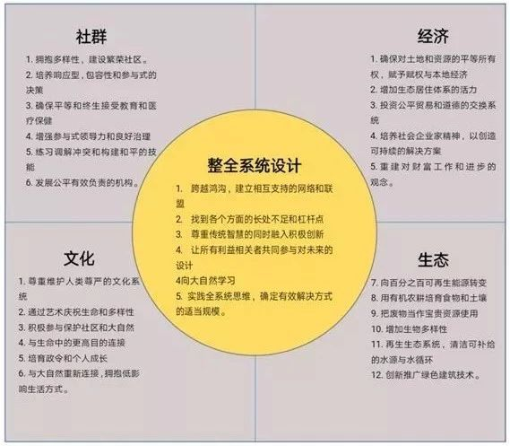

- UNESCO Accreditation for Education (ESD): Focusing on sustainable development and nurturing the public by focusing on 17 sustainable development goals in 2030, promoting and improving basic education, and reorienting existing education at all levels. A plan for understanding and awareness of sustainability and training in four areas. Each year, through the four camps of spring, summer, autumn and winter, the instructors conduct concentrated face-to-face learning.
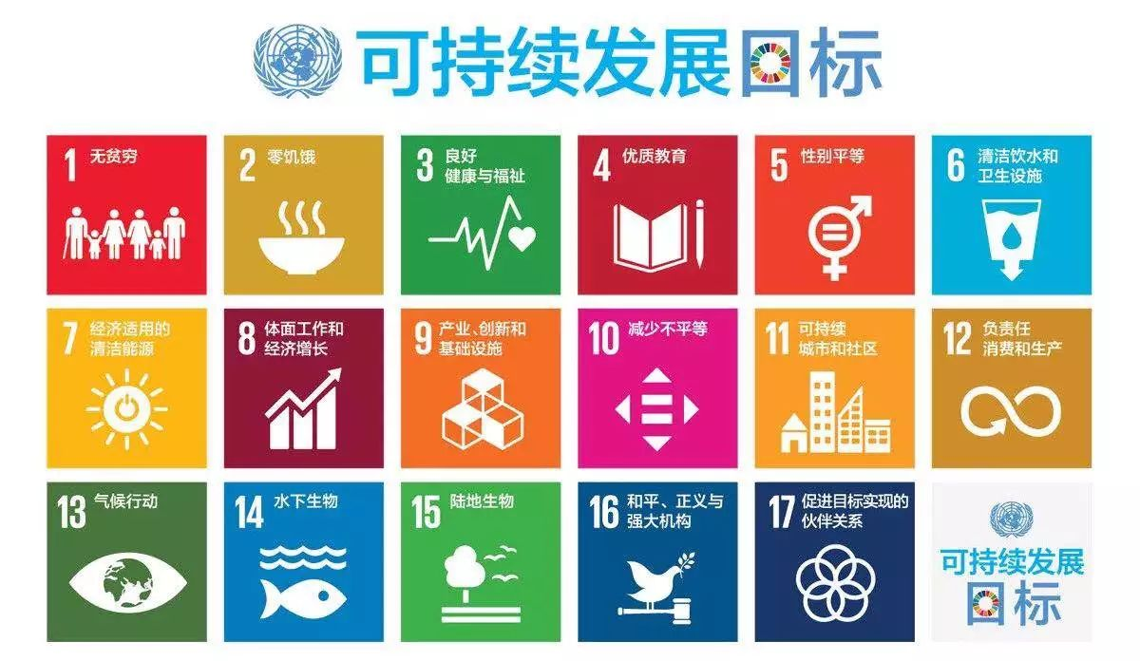
- What will you get from the two-year non-degree program?
1. Overseas ecotourism opportunities
2. Free participation in the ecological workshop held by Sunshine Ecovillage in local areas
3. Living and studying in the Sunshine Ecovillage
4. Have the opportunity tomeet with renowned thinkers such as John B. Cobb, Jr., among others
5. Learn from international, renowned scholars with worldly experiences, and participate in the development of rural revitalization in China;
6. Make more than a dozen like-minded friends and colleagues, get close to nature, and find a meaningful direction of life!
-Learning Method-
1. Inspire discussion style: In practice, you learn through your own experience by learning through the 3-H: hand, head, and heart.
2. Self-participation: participants are encouraged to devise their own course of study within the curriculum.
3. Creative dialogue: Instead of solely emphasizing the teacher's book and lecture, as in modern education, the Academy encourages participants to craft their own discussions and interests through open dialogue. Instead of emphasizing memory, the Academy emphasizes creative problem solving.

- Registration &Admissions -
Objective
The Academy plans to recruit 10 young participants from the Belt and Road countries and 10 Chinese students (15 Chinese students in the first year) to establish a learning center based on the Sunshine Ecovillage community with the hope of cultivating 100 ecological localized societies in 5 years. Young people, through the Global Eco-Village Network, will deliver graduates to the nation and the Belt and Road countries to provide Chinese experience and Chinese wisdom for global ecological development and sustainability.

Potential Participants
- 18 years old or above, with 1 year or 2 years of free time (1 year must be present, 2nd year optional);
- Those who have a strong interest in rural construction, traditional culture, process philosophy, education for common good, sustainable living, ecological agriculture, ecological economy, and community building, etc;
- Those who have already served NGOs, rural construction, social innovation, sustainable development, or education reform are preferred;
- Have 3 or more years of work experience and have a unique understanding of, reflection on modern crisis, climate change, civilization issues, social development and personal life;
- English level 4 or above, or the same equivalent;
- Those who love and are interested in rural revitalization, nature, and/or ecological civilization construction are preferred;
Enrollment
The academy is looking for about 15 students from China in 2019.

Study Period
March 2019 toMarch 2021.

Application Deadline
The application deadline is February 18, 2019, and we will post an offer notice after February 20.

Certificate
1. Cobb Ecological Academy (Sunshine ecovillage) Diploma (signed by John Cobb);
2. Certificate of completion issued by the Global Eco-Village Network and Gaia Education.
Tuition
The tuition for first year is 30,000 RMB. Participants who participate in the community service, farming or other projects offered by CEASE in the second year may have a chance to waive a portion or the full tuition.
If the participants are unable to pay tuition fees, they can apply for our scholarship. The scholarship will cover half or the whole tuition depends on the nature of the scholarship.
Room and board
1. Room and board costs 12,000 RMB / year approximately. Participants can waive some or all of the room and board expenses through farming and community service offered by the academy.
2. The Academy is a non-profit organization. All funding comesfrom donation and gifts made by individuals, enterprises and other parties.
3. The overseas study tour activities of the Academy are open to the public. Students can choose to participate independently. Students with excellent foreign language can participate in the overseas eco-village study program. In addition to visiting the ecological villages around the world, they can also receive certain subsidies.
Place of study
Sunshine Ecovillage, City of Jiande, Zhejiang Province, China. The Sunshine Ecovillage has relatively simple living conditions but is full of vitality.
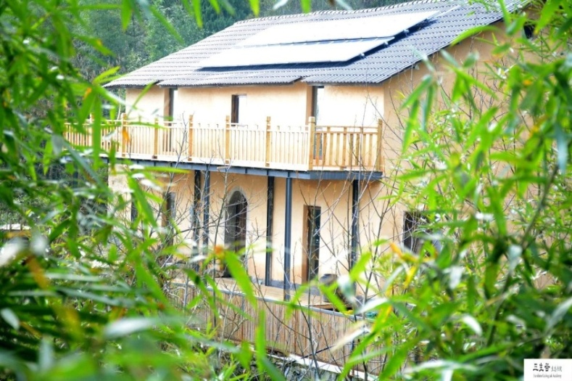

Registration
1. Initial test: The applicant submits the “Cobb Ecological Academy (Sunshine Village) Admission Application Form” (see the end of the article for consultation), along with a recommendation letter and an application paper (3000 words or more). After the initial review, the academy will conduct an online interview for potential students.
2. Re-examination: Each applicant who participated in the re-examination has a three-week experience observation period. After three weeks, the academy decides the final list of admissions according to the specific performance of each student. During this three-week trial period, participants will only need to pay 2,000 RMB for the room and board. The enrolled participants are required to pay tuition of 30,000 RMB a week after admission.

Contact info
Tel: 19957256583
E-mail: CEN20171212@126.con
WeChat: itisxiaogu

